*VoroRock*

*Version 1.0 User Manual*

Qing-Xiang Meng

Department of Civil Engineering

In Hohai University

Nanjing, China 210098

E-mail: mqx4088@gmail.com

February 2019

1. Introduction

This open source code is as a part of the manuscript “Numerical Homogenization Study on the Effects of Columnar Jointing Structure on the Mechanical Properties of Rock Mass”. It is a python code incorporated with the ABAQUS. This short code not only has the ability for the FEM modeling of periodic GBM structure but also can generate files for DEM modeling code like PFC and UDEC. Hope this code is helpful for the related analysis in this topic.

A brief program summary of the package is as follows:

Licensing provisions: **GNU General Public License, version 3**

Programming language: **Above ABAQUS 6.14**

Computer: **Any workstation or laptop computer with ABAQUS**

Operating system: **Linux, Windows, or Mac OS X**

2. Parameter and run

**2.1 Parameter setting**

The basic parameters for this code are list as follows:

domain: the width and height of the numerical model, for example (1,1);

gt: the grain interface thickness, for example 0.01

seedname: the file with the position information of the seed;

error: the length of small edges which should be removed.

**2.2 Run in ABAQUS**

Before run the code, it is noted the path the file should be modified in your computers. The path of the folder of “VoroRock”need to be changed to the folder of your computer in the line 6 of “main.py”. For example:

os.chdir(r'C:\Temp\VoroRock')

After the path and parameters is setted properly, the code can be used using ABAQUS GUI or command mode.

For ABAQUS GUI model:

(1) Open >File > Run Script

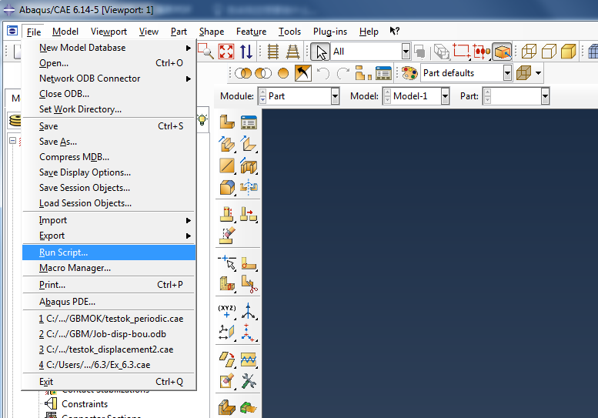

(2) Find the path of OpenGBM and select the “main.py”

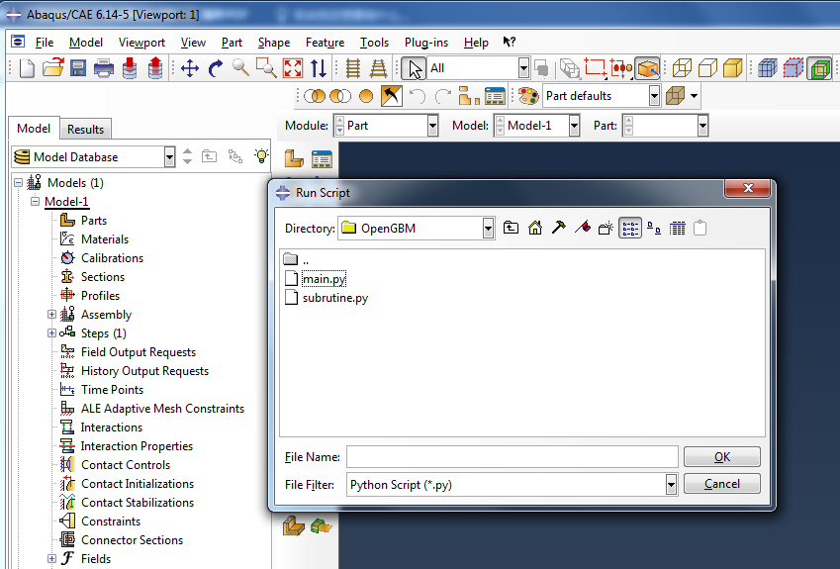

For ABAQUS command line model, just run the code:

abaqus cae nogui= main.py

3. Example demostrartion

**3.1 ABAQUS**

After the runing of the “main.py” is done, two parts can be seen in the model. One is IniGBM and another is “GBM”.

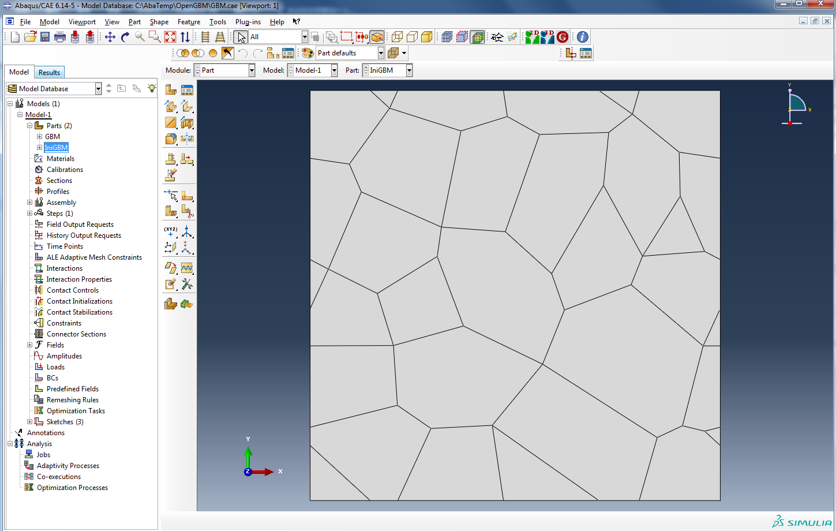

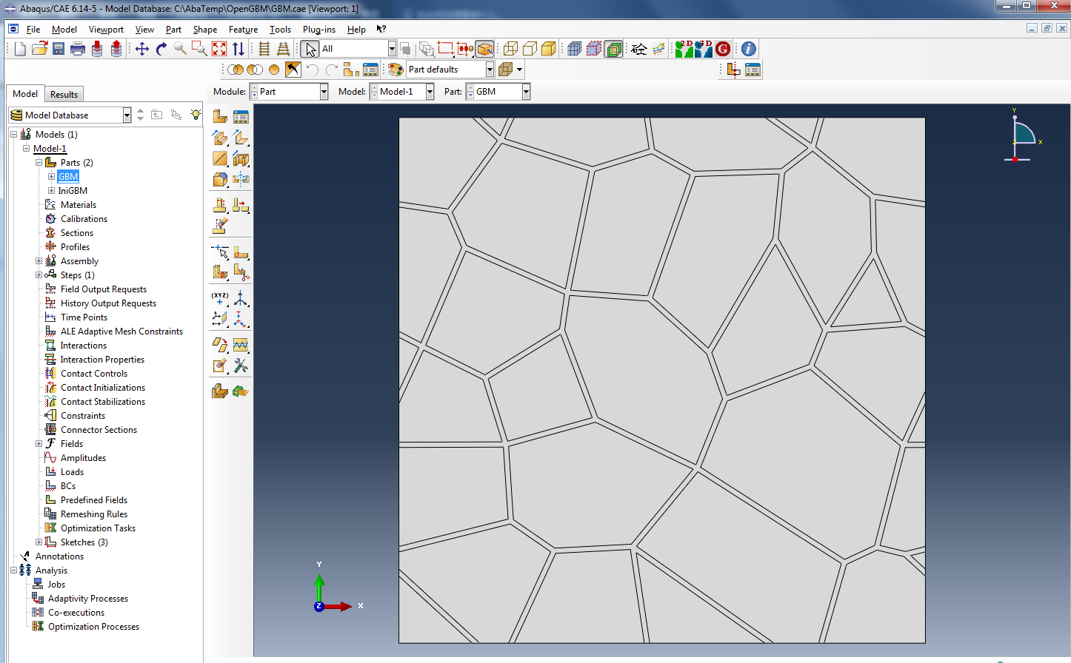

Besides, PFC and UDEC files are also generated in the file folder.

**3.2 PFC**

For PFC modeling, two files namely “GBM.p2dat” and “GBM_Fracture.p2dat”. The DFN information of GBM structure is listed in “GBM_Fracture.p2dat”. After running the “GBM.p2dat”, the fractur and contact information figures is as follows:

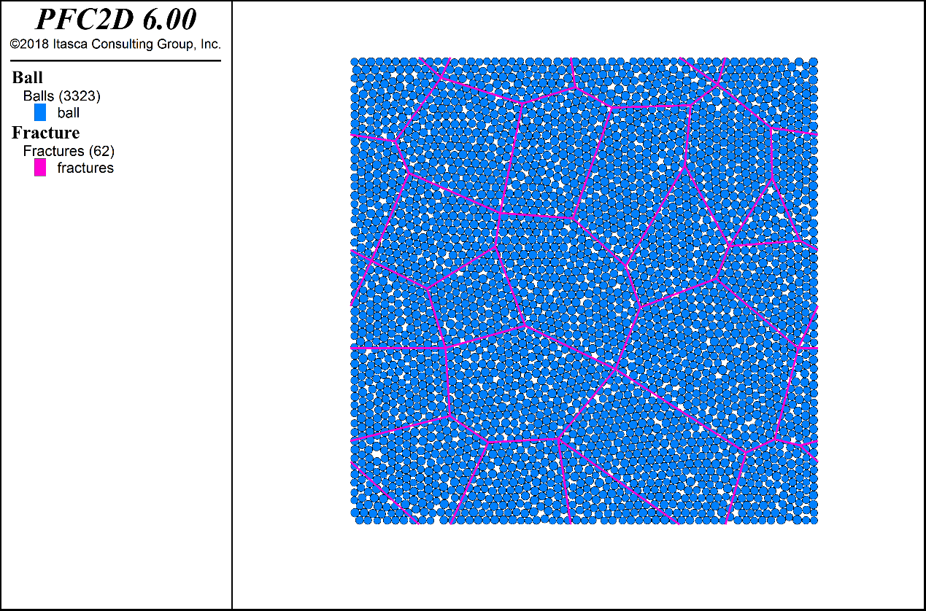

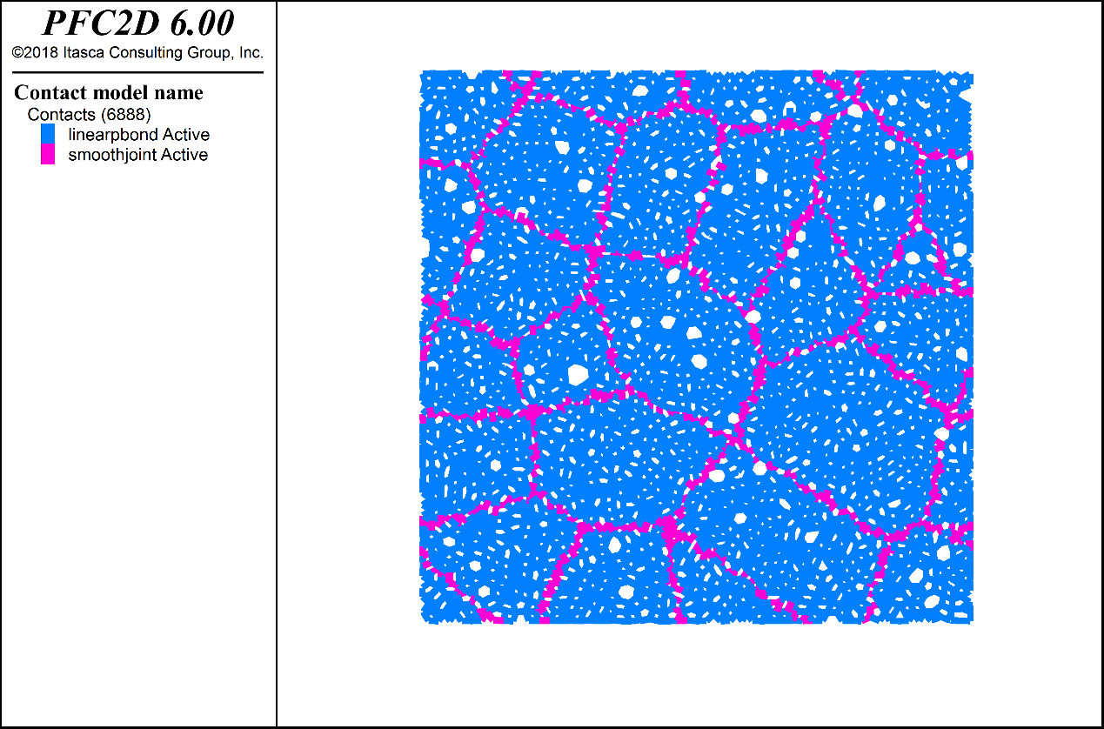

**3.3 UDEC**

Run the “GBM.uddat” in UDEC and the grain structure model is shown as follows:

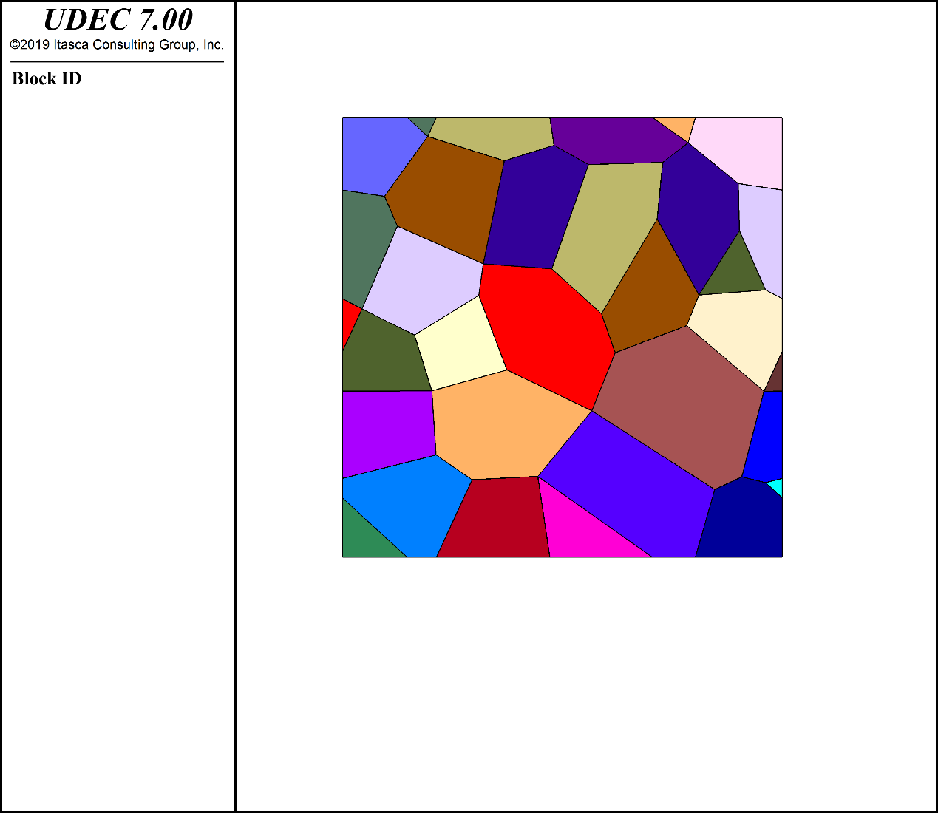

4. Acknowledgement

The author would like to thank the support of Powerchina Huadong Engineering Corporation and Hydrochina-Itasca R&D Center. This code is still under development and more function will add to the code in the near future. If you have any problem in using the code, please feel free to contact the author: